SPIKE: Auto-Enablement of the new Maps experience

**To Enable the Enhanced User Experience on Salesforce Maps**

Go to remote Site Settings: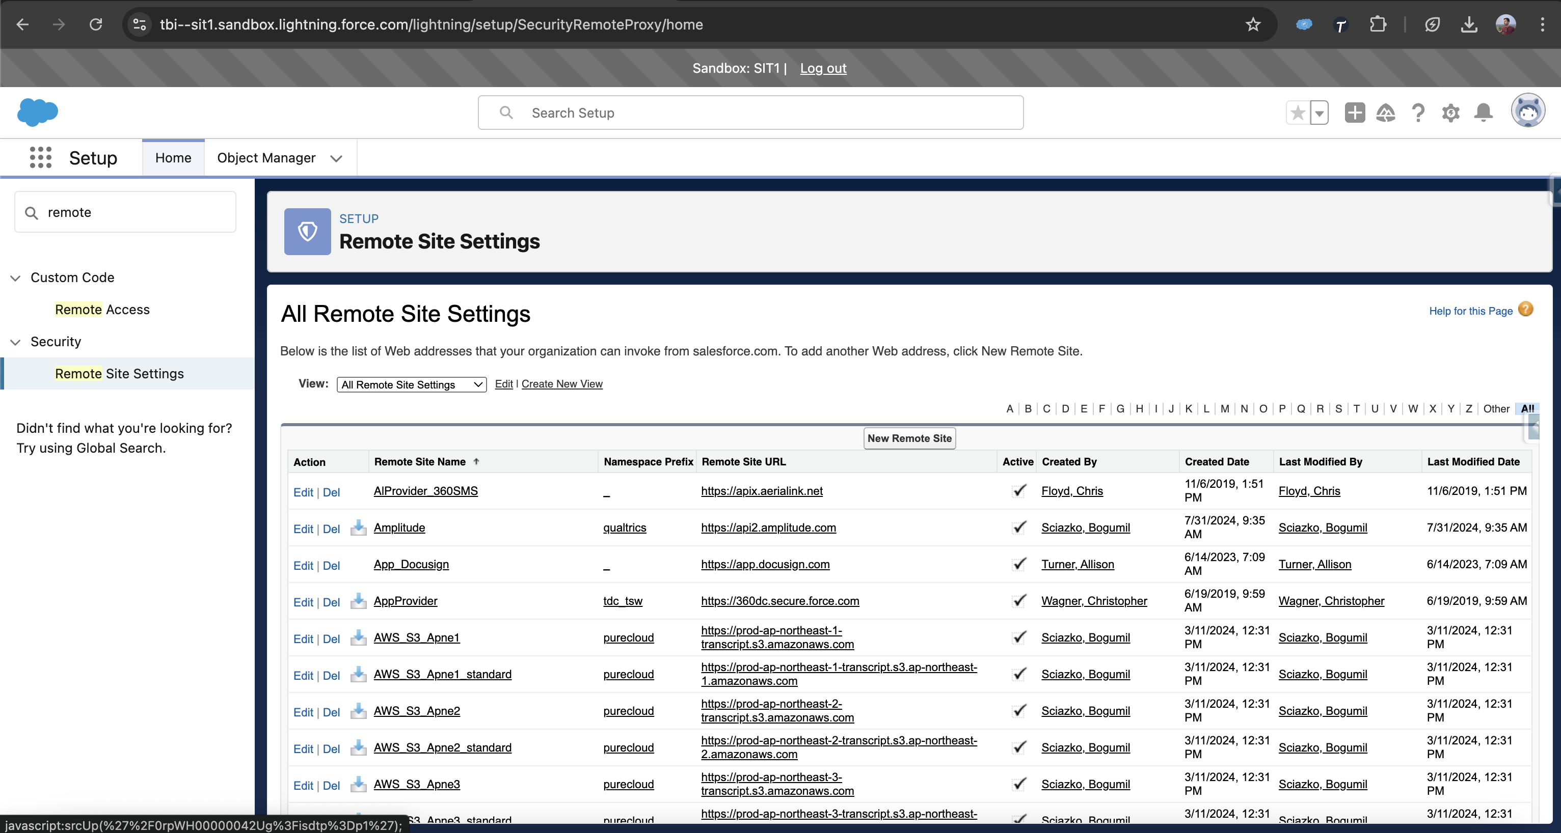

Active these 3 HereAPI for Salesforce Maps



Go to Installed Packages and configure Salesforce Maps

In the Se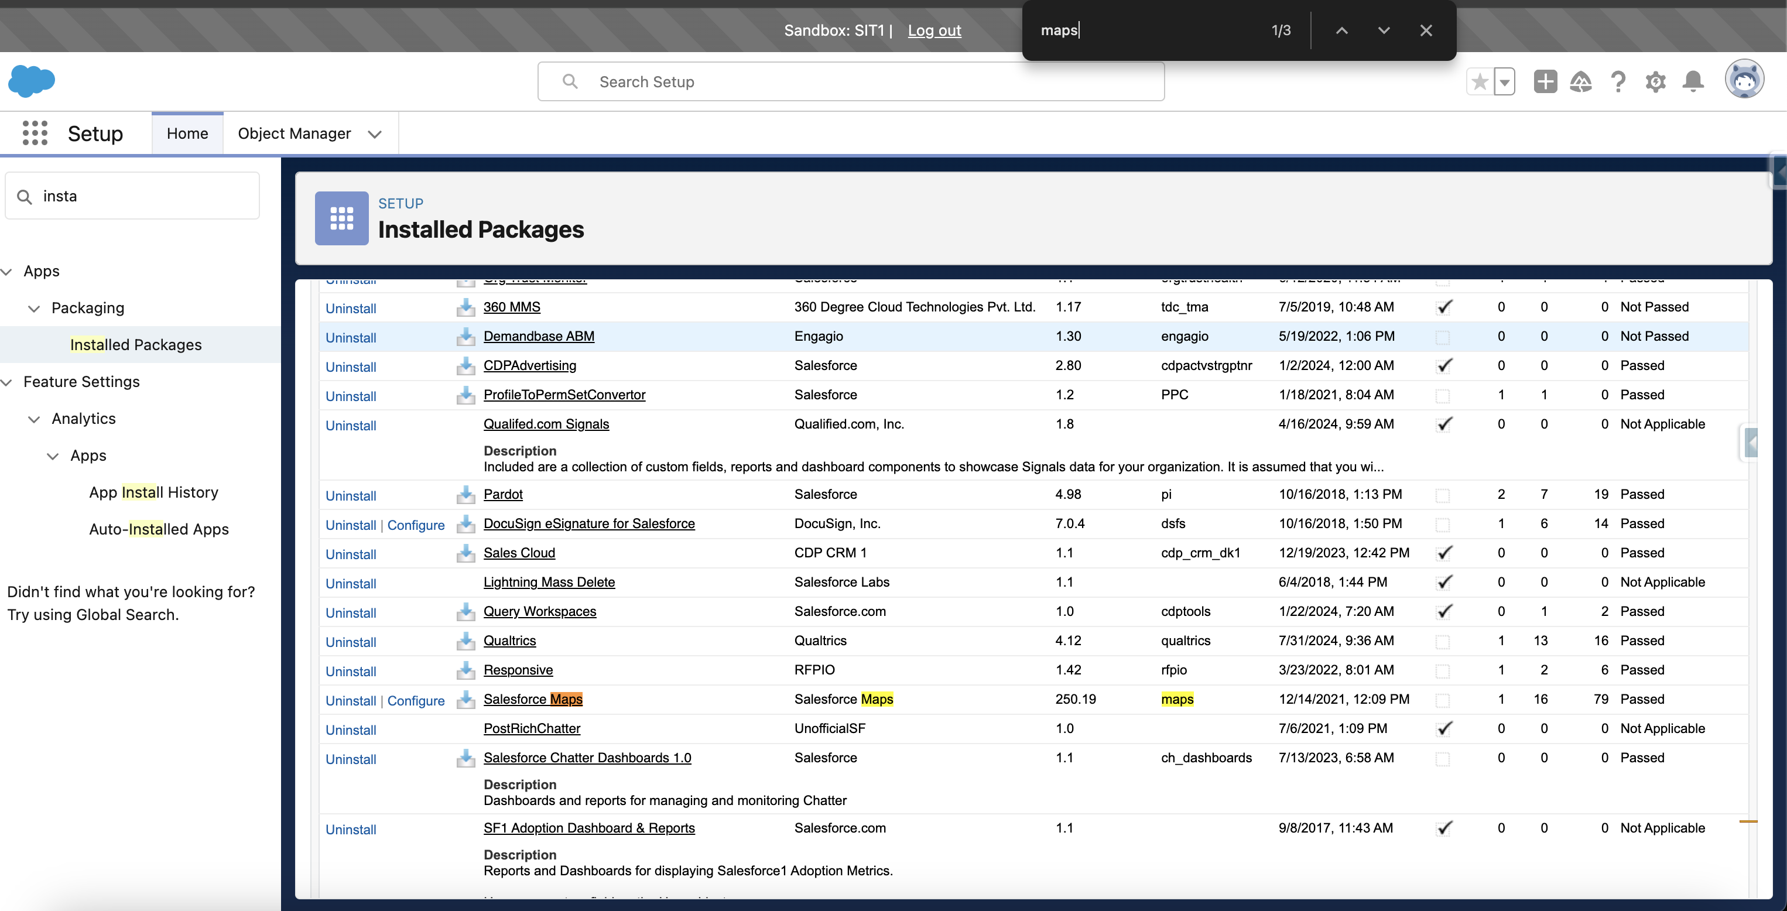ttings Enable the Enhanced User Experience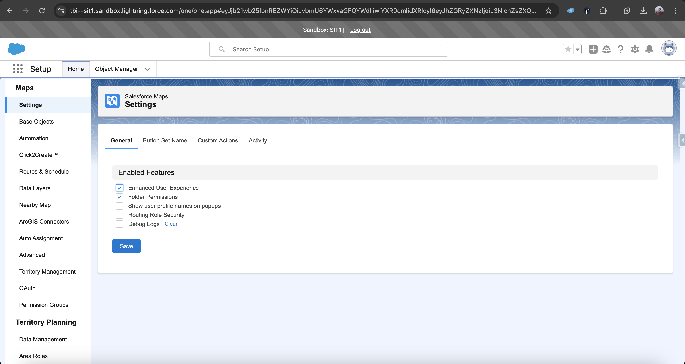

Reference Article: <https://help.salesforce.com/s/articleView?id=sf.salesforce_maps_setup_what_appears_on_maps_enhanced_framework_enable.htm&type=5>